|  |  |  |  |
| --- | --- | --- | --- |
|  | Bansilal Ramnath Agarwal Charitable Trust's  Vishwakarma Institute of Information Technology  **Department of**  **Artificial Intelligence and Data Science** | | |
| Name: Siddhesh Dilip Khairnar | | | |
| Class: SY | Division: B | | Roll No: 272028 |
| Semester: IV | | Academic Year: 2022-2023 | |
| Subject Name & Code: ES22201AD: Probability and Statistics | | | |
| Title of Assignment: Hypothesis testing in R | | | |
| Date of Performance: 27-04-2023 | | Date of Submission: 27-04-2023 | |

**ASSIGNMENT NO. 7**

**Background information:**

Hypothesis testing is a statistical method that allows us to test whether there is a significant difference between two groups, or whether a certain relationship exists between two variables. In hypothesis testing, we formulate a null hypothesis (H0) that assumes there is no difference or relationship, and an alternative hypothesis (Ha) that assumes there is a difference or relationship. We then use statistical methods to determine the likelihood of the observed data given each hypothesis.

In R, there are several packages that can be used for hypothesis testing, including `stats`, `car`, and `psych`. Here is an example of how to perform a hypothesis test using the `t.test()` function from the `stats` package:

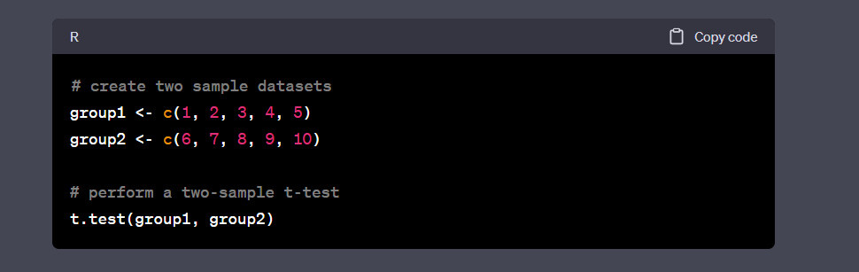

This will perform a two-sample t-test between `group1` and `group2`, and output the results including the p-value. The p-value represents the probability of observing the data given the null hypothesis, and a small p-value (typically less than 0.05) indicates that the null hypothesis should be rejected in favor of the alternative hypothesis.

You can also perform other types of hypothesis tests using R, such as chi-square tests or ANOVA tests, depending on your research question and data.

**Conclusion:** We have successfully implemented hypothesis testing (z-test and t-test) in RStudio.